1. When we select the packing of boxes, the delivery fee is still applying. Please adjust so if selected that delivery does not apply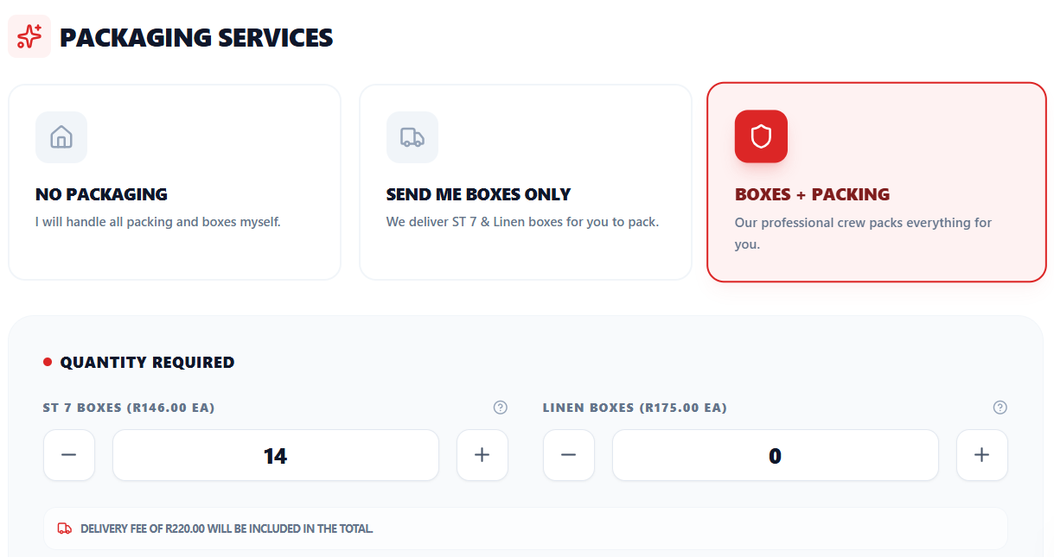
3. Boxes were supposed to be added to every room and some furniture items and server needs to be added to lounge, dinning room and study. Refer to full list of inventory of sheet in folder called “Additional items to rooms with volumes.xlsx” – please make sure every single item of this spreadsheet is in the inventory
4. Search. At inventory not searching all the rooms. We need to at least be able to search an item and if not in the specific room, it should bring up the item regardless of which room it is in.

5. Payflex Option Wording
On the payment side, is it possible to adjust the phrasing for the Payflex option? Instead of explicitly listing a "7% surcharge" to the client, it would look much more professional and seamless if the system just stated that "service fees apply."
6. Screenshot is a example but if address is not added correctly with google maps it should not let user proceed because the address is incorrect. It must be a google maps address
